9ICEG Late-Breaking Abstract
[Title format: 14pt Arial, bold, center aligned]

N. G. Neer¹, and C. O. Author²

¹Title(s), Institution/Company/University, City, Country, email: imauthor@abcd.com
²Professor, Wonder University, Metropolis, Wonderland, email: co.author@wonder.edu.gr

INTRODUCTION & SCOPE OF WORK

The authors of the abstracts should prepare their contributions in accordance with the layout instructions. In order to ensure a uniform layout, the authors are encouraged to assemble their paper using the provided template. The Conference Header will appear only in the first page. The late-breaking abstract should summarize the key points of the research. It should include a brief introduction on the objectives of the work presented, description of the methodology and major research outcomes.

METHODOLOGY

The main body should be written in 10-pt Arial style.
The abstracts may also include diagrams, graphs, charts and photos. 1 or maximum 2 illustrations are preferable. To assist formatting, authors are advised to place the illustration within a 2-row, 1-colum table with no-borders. The figure will cover the top row with central alignment followed by the figure caption within the bottom raw of the table with central alignment also. The figure caption should it Italic style.
All paragraphs are separated by 6pt spacing.
The extended abstract should not exceed 2 pages.

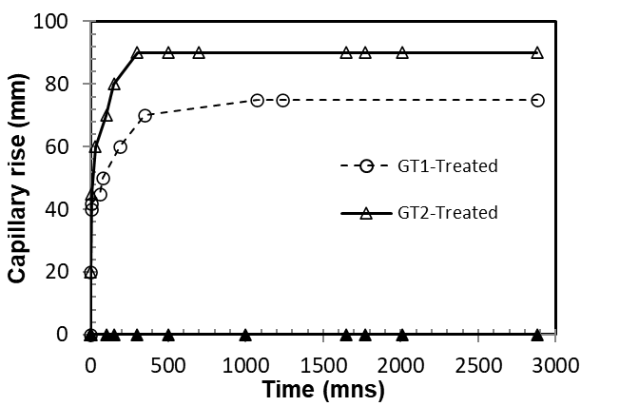
Figure 1. Figure caption written in 10pt Arial text, italic, justify aligned

RESEARCH OUTCOMES

All references must be cited in the text such as Wald et al. (2008) or Peterson (2011). An alphabetical list of References should be included at the end of the paper. References will be written in 9-pt Arial style.

REFERENCES

Abbott, A. B., Name2, C. D., Name3, E., & Name4, F. (2010). Settlement analysis of municipal solid waste. Journal of Environmental Engineering, 130(8), 1272-1279.
Beacher, F. G. (2011). Remediation of arsenic-contaminated soils. In H. I. Bowders, & J. Smith (Ed.), International Conference on Soil Remediation, (pp. 152-167). Cardiff, U.K.
Collins, K., & Name7, M. (1998). Waste Containment Facilities. Melbourne: CRC Press.
Douglas, N. (2021). Review of remediation techniques. Retrieved October 2, 2022, from ABCD: http://www.abcd.com

